Test cases Screen Shot

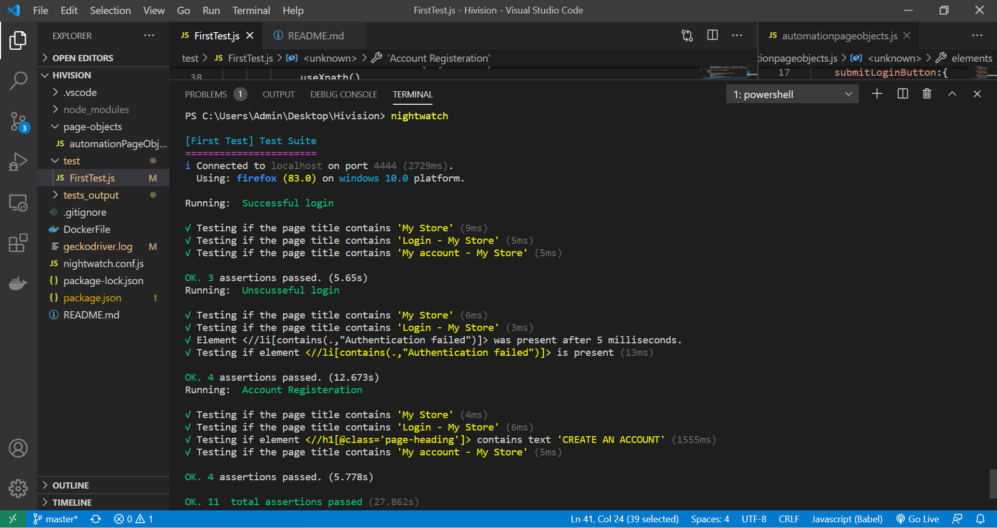

Failed to apply OOP and containerize the project.

Page objects are added only to the Successful login test and Unsuccessful login.